Experiment: 9

Student Name: Sahil Goyal UID:24BDA70148
Branch: CSE Section/Group: AIT-KRG-GP2
Semester: 4th Date of Performance:17/04/2026
Subject Name: DBMS

- Aim of the practical: To create and implement PL/SQL packages by developing a package specification and package body containing procedures and shared cursors, in order to achieve modular, reusable, and efficient database programming.

2. Tool Used:
● Database Management System:

○ PostgreSQL

● Database Administration Tool:

○ pgAdmin

- Objective:
To design and implement a PL/SQL package that includes procedures and shared cursors for structured and modular program development.

- Practical / Experimental Steps

Step 1 :Create the base table (Employee) with appropriate attributes such as employee ID, name, department, and salary.
Step 2 : Insert sample data into the table to simulate real-world employee records.
Step 3: Design a package-like structure by creating a schema (in PostgreSQL) or package specification (in Oracle) to declare procedures/functions.
Step 4: Implement procedures/functions to fetch and display employee details.
Step 5: Define and use a shared cursor (or cursor logic) to retrieve employee records efficiently within the procedures.
Step 6: Execute the created procedures/functions to display all employee records and filtered results (e.g., by department).

- I / O Analysis

CREATE TABLE employee (
emp_id INTEGER PRIMARY KEY,
emp_name VARCHAR(50),
department VARCHAR(50),
salary NUMERIC
);
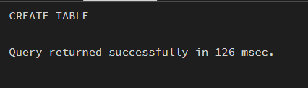

INSERT INTO Employee VALUES (101, 'Amit', 'HR', 30000);
INSERT INTO Employee VALUES (102, 'Riya', 'IT', 50000);
INSERT INTO Employee VALUES (103, 'Karan', 'Finance', 45000);
INSERT INTO Employee VALUES (104, 'Neha', 'IT', 55000);
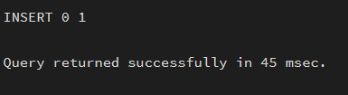

CREATE SCHEMA emp_package;
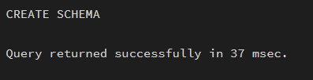

CREATE OR REPLACE FUNCTION emp_package.get_all_employees()
RETURNS VOID AS $$
DECLARE
emp_rec RECORD;
BEGIN
FOR emp_rec IN
SELECT * FROM employee
LOOP
RAISE NOTICE '% % % %',
emp_rec.emp_id,
emp_rec.emp_name,
emp_rec.department,
emp_rec.salary;
END LOOP;
END;
$$ LANGUAGE plpgsql;
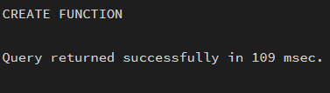

CREATE OR REPLACE FUNCTION emp_package.get_emp_by_dept(p_dept VARCHAR)
RETURNS VOID AS $$
DECLARE
emp_rec RECORD;
BEGIN
FOR emp_rec IN
SELECT * FROM employee
LOOP
IF emp_rec.department = p_dept THEN
RAISE NOTICE '% % % %',
emp_rec.emp_id,
emp_rec.emp_name,
emp_rec.department,
emp_rec.salary;
END IF;
END LOOP;
END;
$$ LANGUAGE plpgsql;
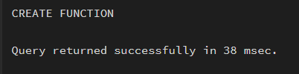

OUTPUT

SELECT emp_package.get_all_employees();
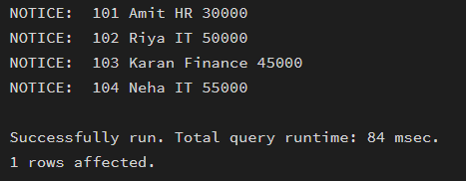

SELECT emp_package.get_emp_by_dept('IT');
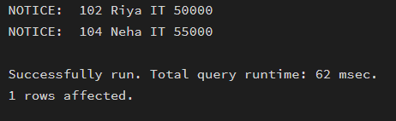

- Learning outcomes (What I have learnt):
- Understand the concept and working of materialized views in a database system.
- Differentiate between simple views, complex views, and materialized views.
- Create and refresh materialized views in PostgreSQL.
- Measure and compare query execution time for different types of views.
- Analyze performance benefits of materialized views in data-intensive applications.
- Apply materialized view concepts in real-world company scenarios such as SanDisk, JTG, and PayPal.

